**Name of Project:- Podcast App: Carol**

**Group No: 14**

1. **Description of Project:-**

Podcast Apps are recently popular and gradually become a new trend among young people. The number of searches for the keyword “podcast” on google has continuously increased over the past five years. And we know there are so many podcasts app available on internet.

Because of abundance of many podcasts, users usually struggle to find a suitable one to listen to when they use a podcast app. Thus, the most essential aim of a podcast app is to help users discover their favourite. Furthermore, the app must pay attention to increasing the interaction and personalizing the experience.

So basically, this podcast app allows you to search, find and listen to a In our podcast app.

we are welcoming our users to the welcome screen as the logo of our app. Then new users have to sign up with their email, user name, password and birth date and gender. And users can simply log in using a username and password. And also modify their password. After successfully entering the app they have to answers some questions like their favourite type of music.

And they can also choose their favourite artists, select music on the page .they can search for any song or podcast or browse types of categories like a live event, radio, a motivational podcasts, Hindi podcasts.

Also, users can view the best episode of the week or they can choose podcasts from creators or selection categories like new releases podcasts, video podcasts, love and relationships, motivation and inspiration, spirituality and deviation etc.

Then users can add their favourite artist or add podcast /show in Library.

And In about us, they can go through about our work.

**Name of Group Members:**

|  |  |  |  |
| --- | --- | --- | --- |
| Sr. No. | Division | Roll No | Name of Students |
| 1 | B | 32 | Anushka Shinde |
| 2 | B | 33 | Purva Shinde |
| 3 | B | 34 | Vaishnavi Shinde |
| 4 | B | 35 | Ashwini Shirke |
| 5 | B | 36 | Ishwari Sonar |
| 6 | B | 37 | Shreya Sonar |

1. **Abstract:**

In recent years, podcast apps have gained immense popularity and have become a new trend among young people. With the increasing number of searches for the keyword "podcast" on Google, it is evident that users are actively seeking new and engaging content. However, the abundance of podcasts available online often makes it challenging for users to find suitable ones to listen to. Therefore, the primary goal of our podcast app is to assist users in discovering their favourite podcasts while also focusing on increasing interaction and personalizing the listening experience.

Upon launching the app, users are greeted with a visually appealing welcome screen featuring the app logo. New users are required to sign up using their email, username, password, birth date, and gender. For returning users, a simple username and password login option is provided, along with the ability to modify their password if necessary. Once inside the app, users are prompted to answer questions about their favourite type of music to tailor recommendations to their preferences.

The app offers various ways to explore and discover podcasts, including searching for specific shows or episodes, browsing through categories such as live events, radio, motivational podcasts, and Hindi podcasts. Users can also access curated lists of the best episodes of the week or choose podcasts from creators or selection categories like new releases, video podcasts, love and relationships, motivation and inspiration, spirituality, and more.

To enhance personalization, users have the option to add their favourite artists or podcasts to their library, making it easy to access and manage their preferred content. Additionally, the "About Us" section provides users with insights into the app's work and mission, fostering a sense of connection and transparency.

By combining a user-friendly interface, personalized recommendations, and a comprehensive library of podcasts, our innovative app aims to empower users to effortlessly search, find, and listen to their favourite content, ultimately enhancing their podcast listening experience.

1. **System Concept Statement:**

**System Name: Podcast App: Carol**

The podcast app's name is Carol app.

Podcast listeners tend to be younger, early adopters of technology who can be difficult to reach using traditional advertising channels. And mid-aged people who love to listen to a podcast like news, live event, etc. and aged people who love spiritual podcasts. so, users can be anyone who loves to listen.

Our podcast system's mission is to create a dynamic and engaging platform that enables creators to share their stories, ideas, and perspectives with a global audience.

Users will be able to listen different Songs, podcast etc. Users can also choose their favourite artists, select music on the page. Users can search for any song or podcast or browse types of categories like a live event, radio, a motivational podcast, Hindi podcasts.

The Content or stream will record in high quality. And Provide User Friendly User-Interface. Our Carol app provide real-content of podcast.

1. **Intended audience, acronyms, and abbreviations**

The podcast app project is developed with a diverse audience of podcast enthusiasts in mind. The application targets the following user groups:

Podcast Lovers: Individuals who have a deep love for podcast and enjoy building and curating their personal podcast libraries. They appreciate having a convenient and user-friendly platform to manage and listen to their favorite podcasts.

Casual Listeners: Users who enjoy listening to podcast on a regular basis but may not have extensive knowledge or expertise in managing podcast collections. The application provides a simple and intuitive interface for effortless podcast playback and organization.

Podcast Discovery Seekers: Users who are eager to explore and discover new artists, podcast, and category. The integration with online podcast libraries and personalized recommendations feature will be valuable to those who want to broaden their podcast horizons.

Multi-Platform Users: People who use multiple devices and platforms to access their podcast. The compatibility of the application across various devices and operating systems ensures a consistent and seamless podcast listening experience.

Security-Conscious Users: Individuals who prioritize the security and privacy of their personal data. The implementation of robust security measures within the application will instill confidence and trust among security-conscious users.

All Age Groups: The podcast app is designed to be accessible and enjoyable for users of all age groups, from young podcast enthusiasts to older adults.

The project aims to cater to the diverse needs and preferences of this audience by providing a comprehensive and user-friendly podcast app that enhances their music listening experience, offers customization options, and ensures compatibility across multiple platforms.

1. **Functional and non-functional requirements**

* **Functional Requirements:**

1. User Registration: Users should be able to create an account on the Carol app, providing their basic details such as name, email address, and password.

2. User Profile: Users should have a profile where they can manage their preferences, favourite podcasts, and artists. They should also be able to view their listening history and customize their profile settings.

3. Podcast Discovery: The app should provide a search function to allow users to find specific podcasts, artists, or episodes. Users should also be able to browse podcasts by categories such as news, live events, motivational podcasts, spiritual podcasts, etc.

4. Podcast Streaming: Users should be able to stream podcasts directly from the app. The app should support high-quality audio streaming to ensure a good listening experience.

5. Playlist Creation: Users should be able to create and manage their own playlists by selecting songs, episodes, or podcasts. They should also be able to save their favourite episodes for easy access.

6. Recommendations: The app should provide personalized recommendations based on the user's listening history, preferences, and trending podcasts. This can help users discover new podcasts and artists they may be interested in.

7. Offline Mode: Users should have the option to download podcasts or episodes for offline listening. This is useful when users are in areas with limited or no internet connectivity.

8. Social Sharing: Users should be able to share their favourite podcasts, episodes, or playlists on social media platforms to recommend them to others.

* **Non-functional Requirements:**

1. Performance: The app should be responsive and provide smooth playback even with a large number of concurrent users. The streaming should be fast and seamless, without buffering or interruptions.

2. Security: User data should be securely stored and transmitted. The app should implement measures such as encryption, secure login, and protection against unauthorized access.

3. Scalability: The app should be designed to handle increasing user traffic and growing content libraries. It should be able to scale up the infrastructure as needed to ensure a consistent user experience.

4. Usability: The user interface should be intuitive and easy to navigate, catering to users of different age groups and technological expertise. The app should provide clear instructions and feedback to guide users in using its features.

5. Compatibility: The app should be compatible with different devices and operating systems, including mobile phones, tablets, and desktop computers. It should support popular platforms such as iOS and Android.

6. Accessibility: The app should adhere to accessibility standards, ensuring that users with disabilities can use its features. This includes providing options for larger text sizes, support for screen readers, and compatibility with accessibility features built into the device's operating system.

7. Continuous Improvement: The app should be regularly updated with new features, bug fixes, and performance optimizations based on user feedback and industry trends. Regular updates ensure that the app stays relevant and provides an improved user experience over time.

**5. Design**

**a. User Personas**

**1.User Persona for Anchor**

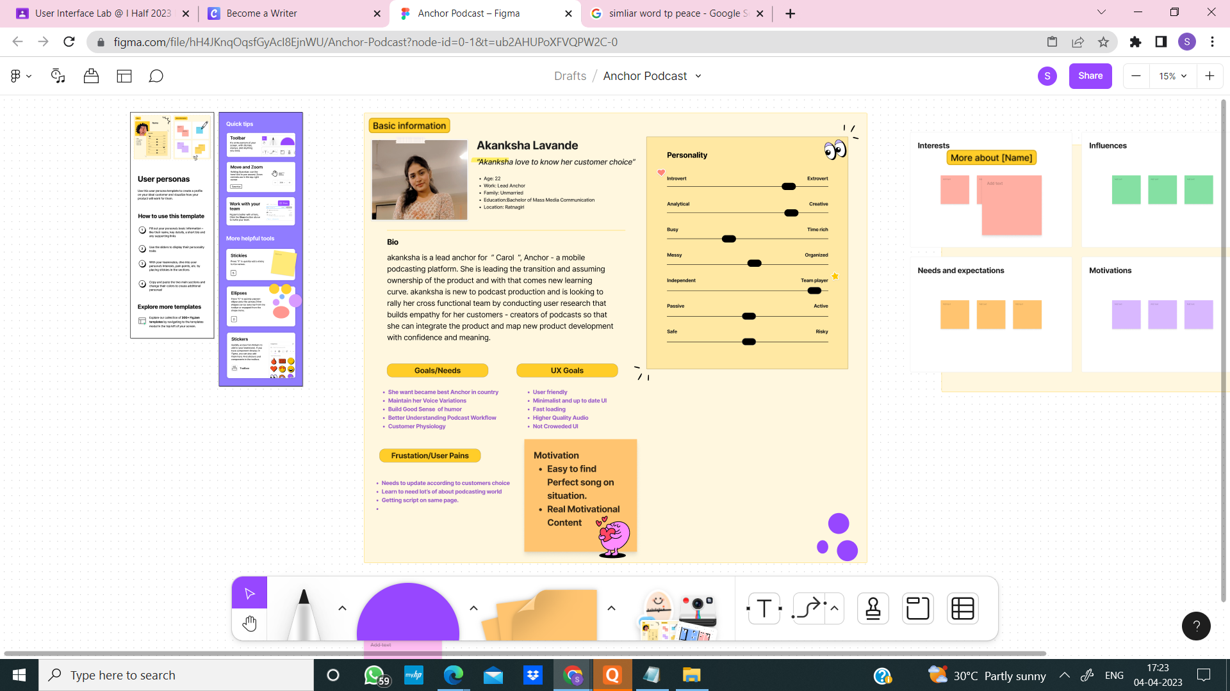

**2.User Persona for Audio Engineer**

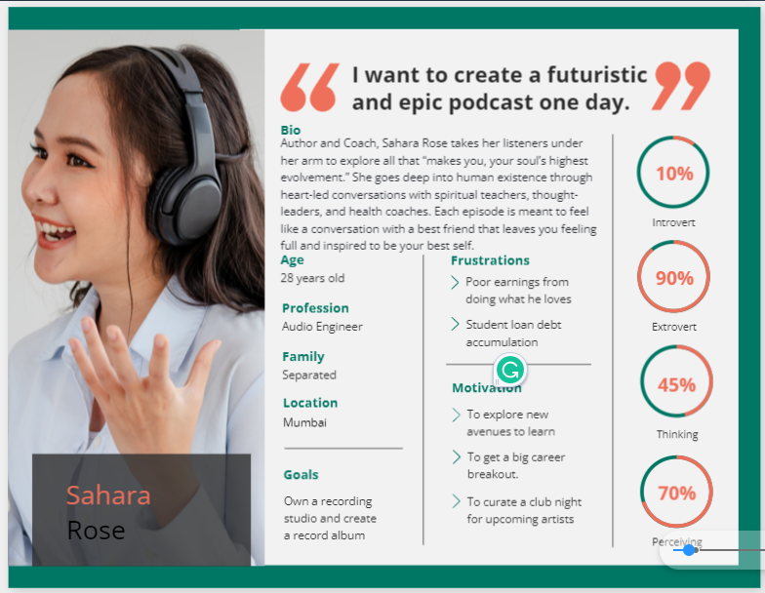

**3.User Persona for Student**

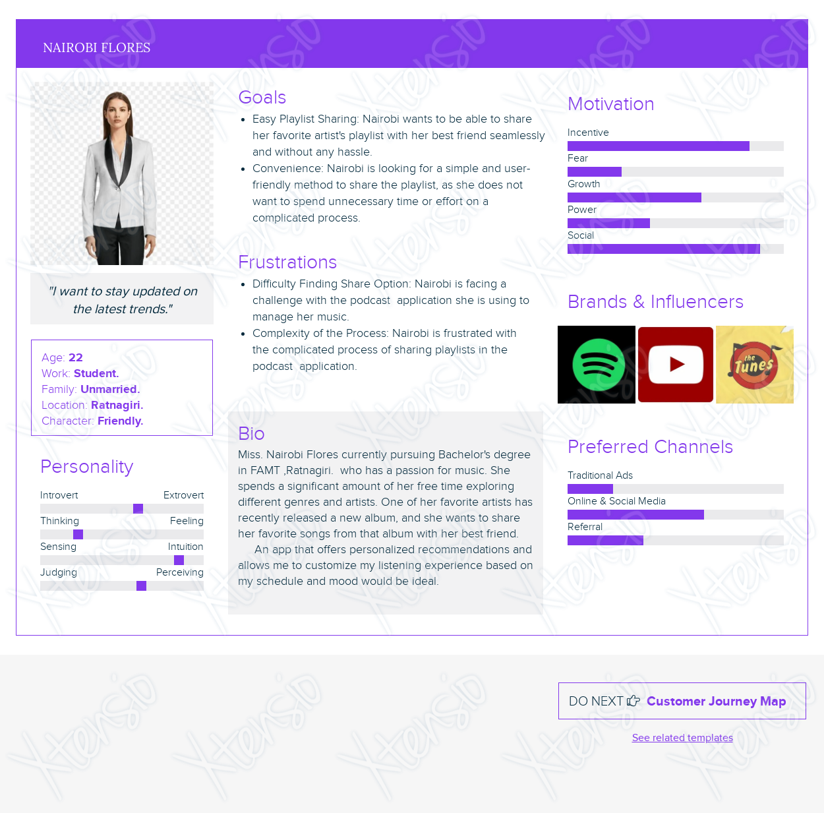

4.User persona for Employee

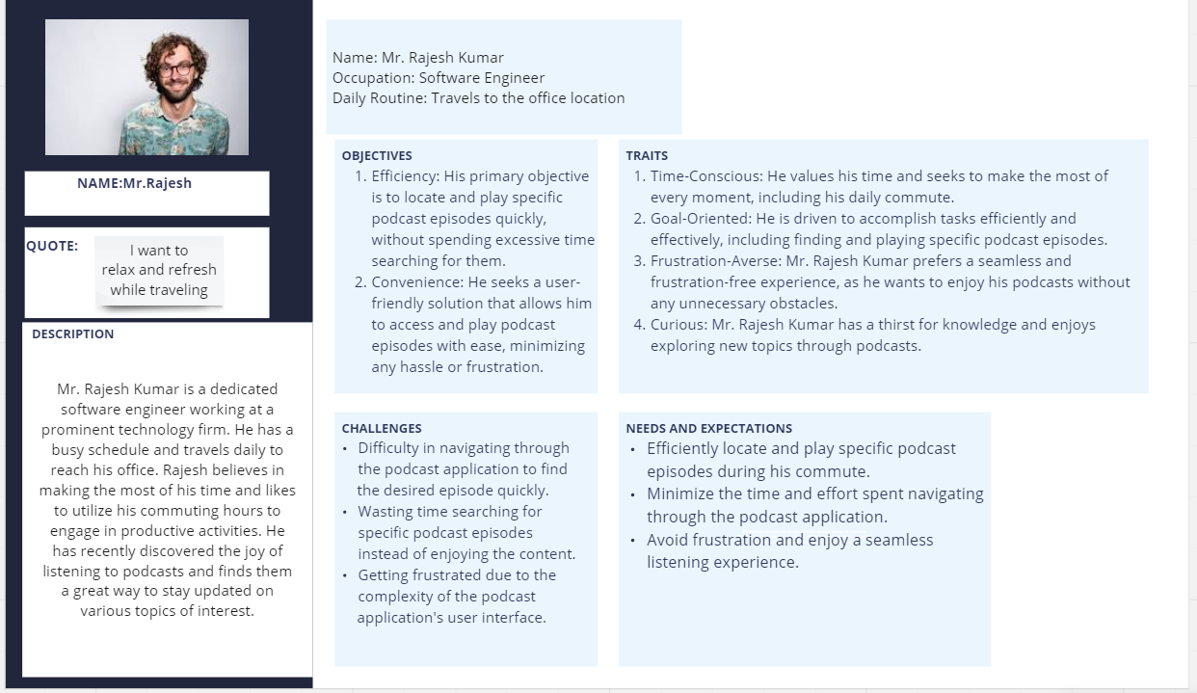

**b. Task analysis model**

**Task 1 : Verifying Artist’s new Work.**

* Assume that Miss Sankalpa is an Admin of ‘**Carol’ .** Now as an Admin Sankalpa wants to verify new work of some artists.
* As an Admin she always need to check and verify work of all artists. So then she can decide whether the work is suitable as a content for the Carol or not.
* But the problem is there are two different major type of media work on Carol. A Podcast and a Song so she wants them in different options and in sorted form also.
* All she need is that two different options Podcast and Song. With more sorted form.

**Goal :** Getting two separate options two different types of media work with more sorted form.

**Subgoals :**

* Open the app on the device.
* Enter Login-id and Password.
* Click on Verify.
* Select option from Podcast and Song.
* Click New Request for verifying new request of work.
* Click Approved to see which work got approved by Admin.
* Click Modified to see which work needs to be improve before going on Carol.
* Exit the ‘Carol’

**Flow Of The Procedure :**

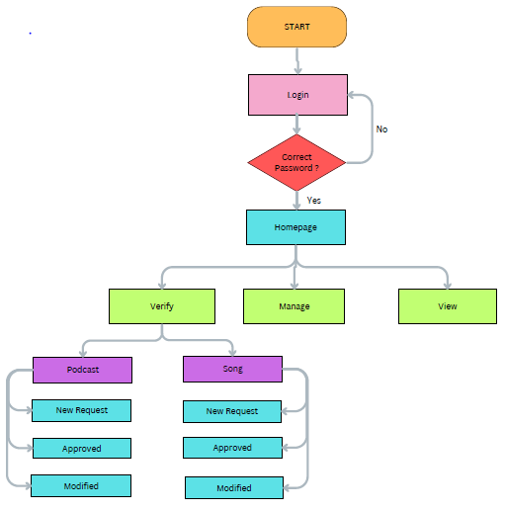

**Task 2: Listen to a podcast episode**

**Goal**: Listen to a podcast episode

* Assume that Mr Rajesh want to listen his podcast while he is traveling.
* Mr Rajesh wants to listen to a specific podcast episode but is having difficulty navigating through the podcast application to find and play the episode.
* And he needs a more user-friendly way to locate and play the desired episode without wasting time and getting frustrated.

**Subgoals:**

**1. Open the Carol** **application**

**2. Find the desired podcast**

**3. Select the desired episode**

**4. Start playing the episode**

**5. Listing podcast.**

**6. Adjust the playback speed, if Required**

**7. Pause or stop the episode, if needed**

**8. Close the application**

**Flow Of the Procedure :**

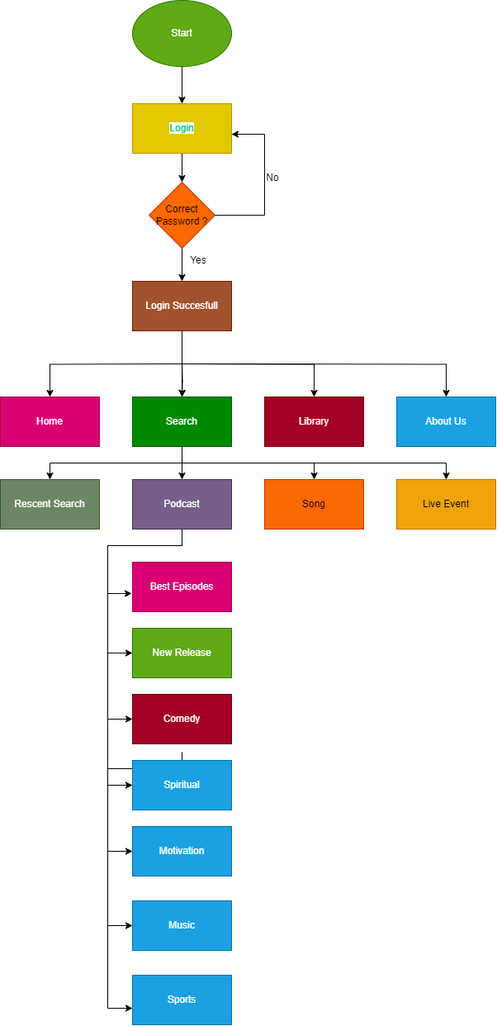

**Task 3 : Sharing a playlist.**

* A Miss Siya, a college student, wants to share a playlist of her favorite songs by her favorite artist with her best friend. However, she is having difficulty finding an option in the Carol application that allows her to share the playlist.
* She needs a way to easily share her playlist with her friend without having to go through a complicated process.

**Goal :** Creating a Share option.

**Subgoals :**

* Open the app on the device.
* Enter Login-id and Password.
* Click on Library.
* Click on My Playlist.
* Click on Share Your Playlist.
* Exit the ‘Carol’

**Flow Of The Procedure :**

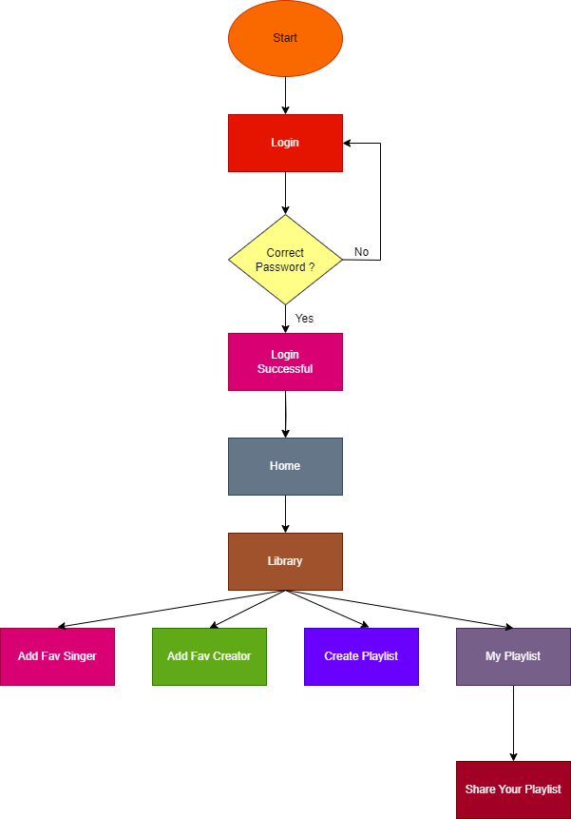

**c. Story board and sketches**

**Task1:Sharing Playlist**

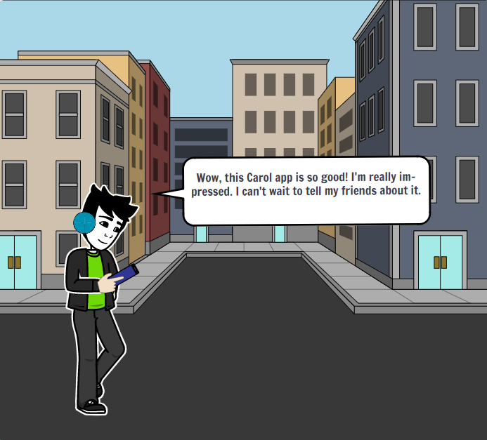

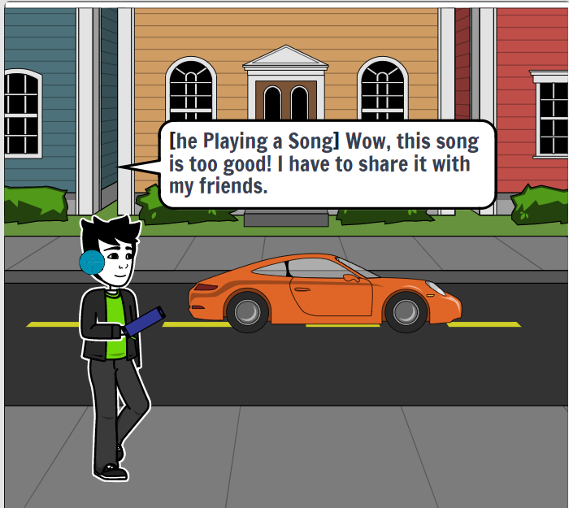

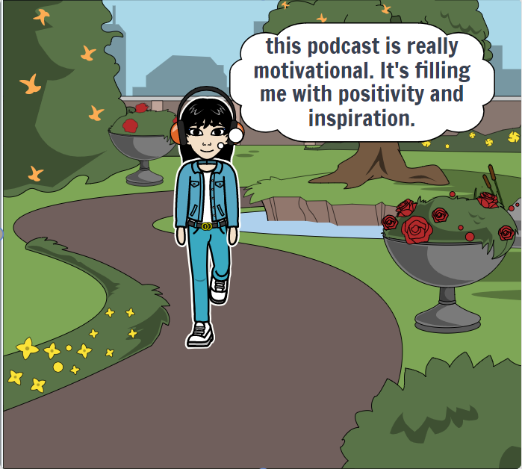

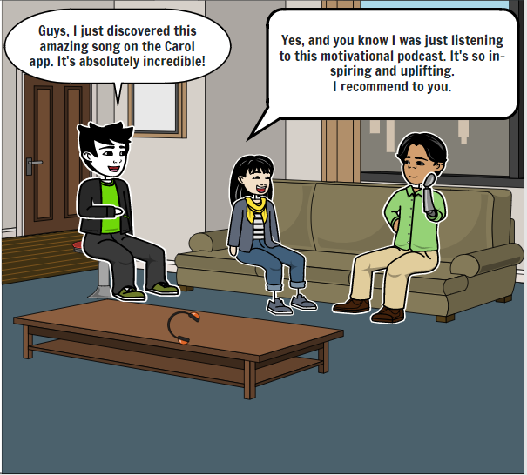

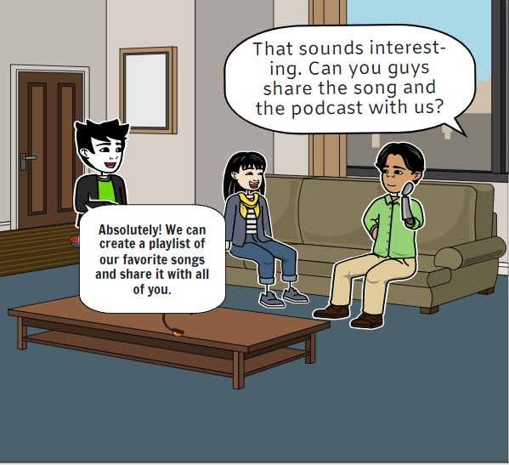

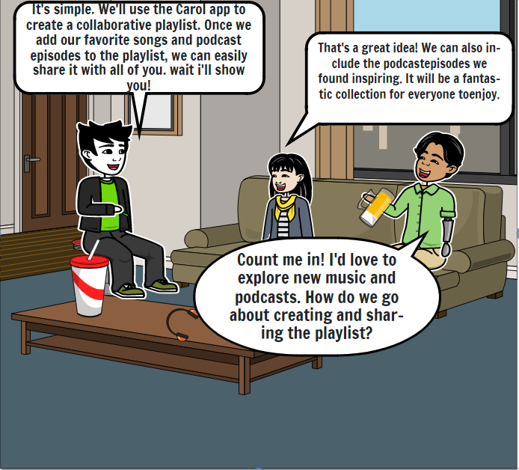

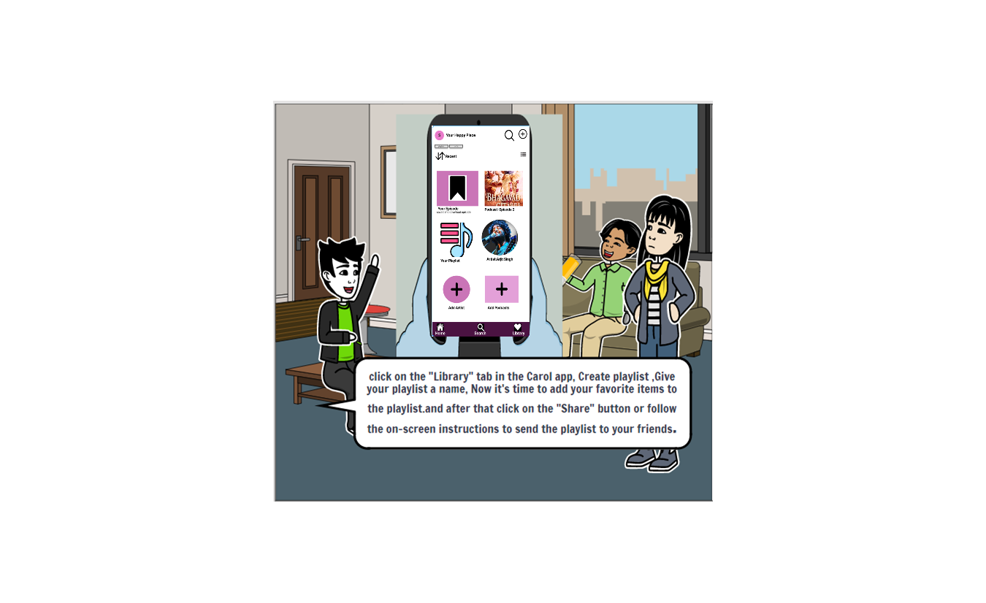

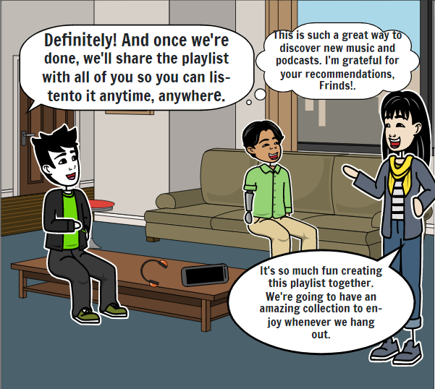 **Story Description –**

In a cosy living room, Miss Siya and the Boy eagerly share their latest music and podcast discoveries with their friends. Inspired by their enthusiasm, they decide to create a collaborative playlist using the Carol app. With each person contributing their favourite songs and podcast episodes, the playlist takes shape, becoming a reflection of their diverse tastes and shared experiences. Laughter and excitement fill the room as they curate a collection that promises to bring joy and inspiration to their gatherings.

As they add the final touches to the playlist, a sense of anticipation fills the air. Miss Siya can't help but smile, envisioning the moments when their friends will listen to the songs and engage with the thought-provoking podcast episodes. The Boy emphasizes how effortless it is to share the playlist, knowing that their friends will have instant access to the curated content. It's a testament to the power of music and podcasts in creating connections and fostering a sense of community. With the playlist now ready to be shared, Miss Siya and the Boy eagerly pass it on to their friends, sparking excitement and gratitude for the shared journey of discovery that lies ahead.

Task 2:Verifying Artist’s New Work

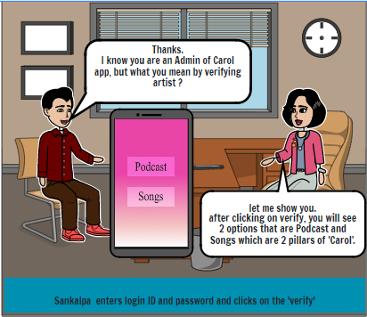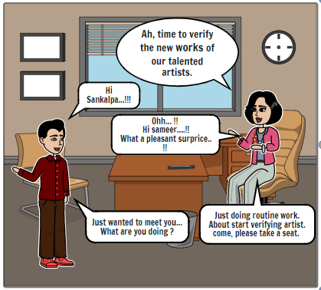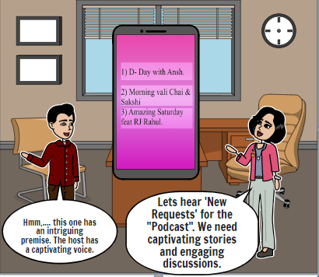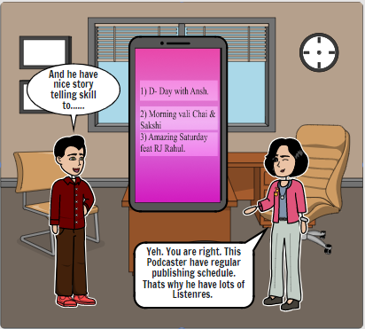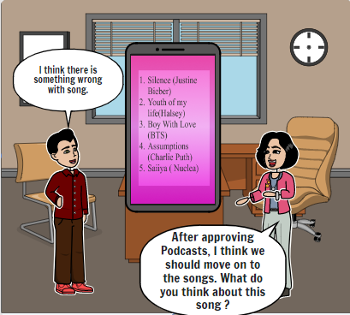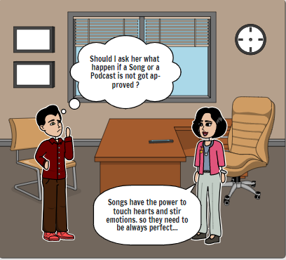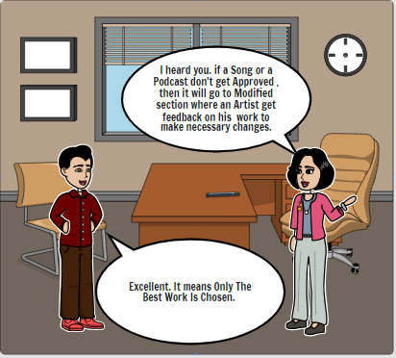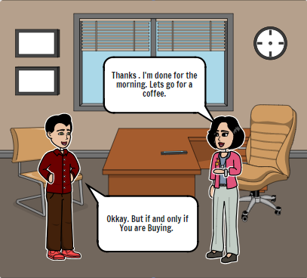

**Story Description –**

Sankalpa, a dedicated curator at the 'Carol' app, begins the day with a sense of excitement as they log in to explore the latest creations from talented artists. With login credentials in hand, they enter the app, eager to discover the new works that await them. Navigating through the interface, Sankalpa clicks on the "Verify" button, knowing that their role is crucial in ensuring the quality and appeal of the podcasts and songs on the platform. With a deep appreciation for both art forms, Sankalpa selects the "Podcast" option and immerses themselves in captivating stories and thought-provoking discussions. Each podcast episode becomes an opportunity for Sankalpa to discern the unique qualities that will engage and captivate the app's audience. Moving on to the songs, Sankalpa embraces the power of melodies and lyrics to touch hearts and evoke emotions. As they listen to each song, Sankalpa carefully evaluates its musicality and resonance, seeking works that will resonate with the app's.

**Task 3:- Search a podcast**

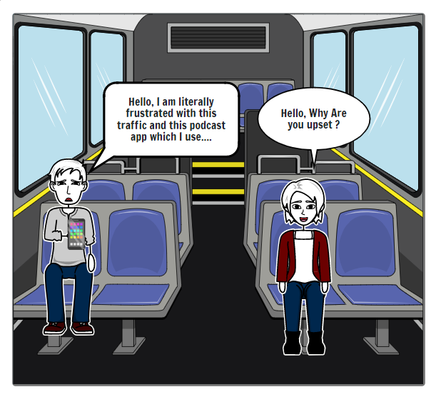

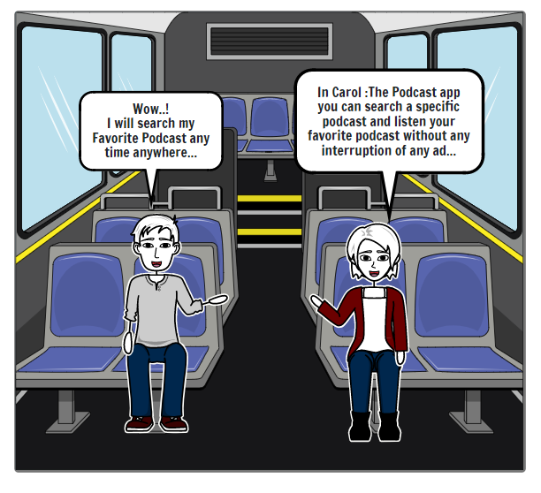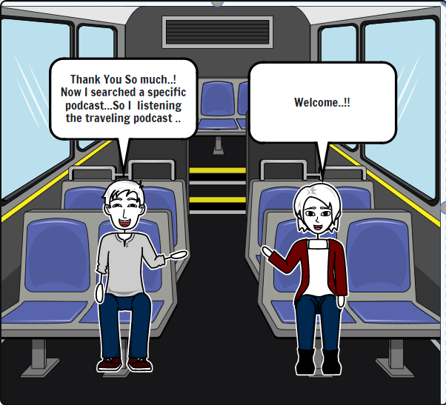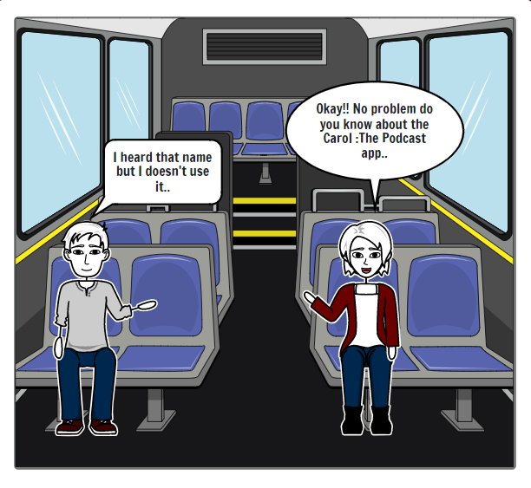

**Story Description –**

Once a boy was traveling by bus. A girl is sitting on the bench next to him. The girl sees the boy very sad so she asks him why are you sad? He says I am literally frustrated with this traffic and this podcast app. She tells him it's no problem at all. Do you know about the Carol app? It is a podcast app. The boy says I have heard the name but I am not using it. As the boy has not used that app, she tells him all the information about that app. You can search for specific podcasts within the app. You can listen to your favorite podcast without any ads. The boy gets happy hearing all this and says I can listen to my favorite podcast anytime anywhere it's great. Thank you very much for giving me this information.

**Task: Sharing a Playlist**

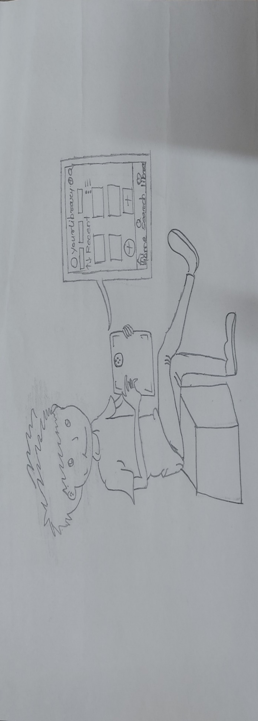

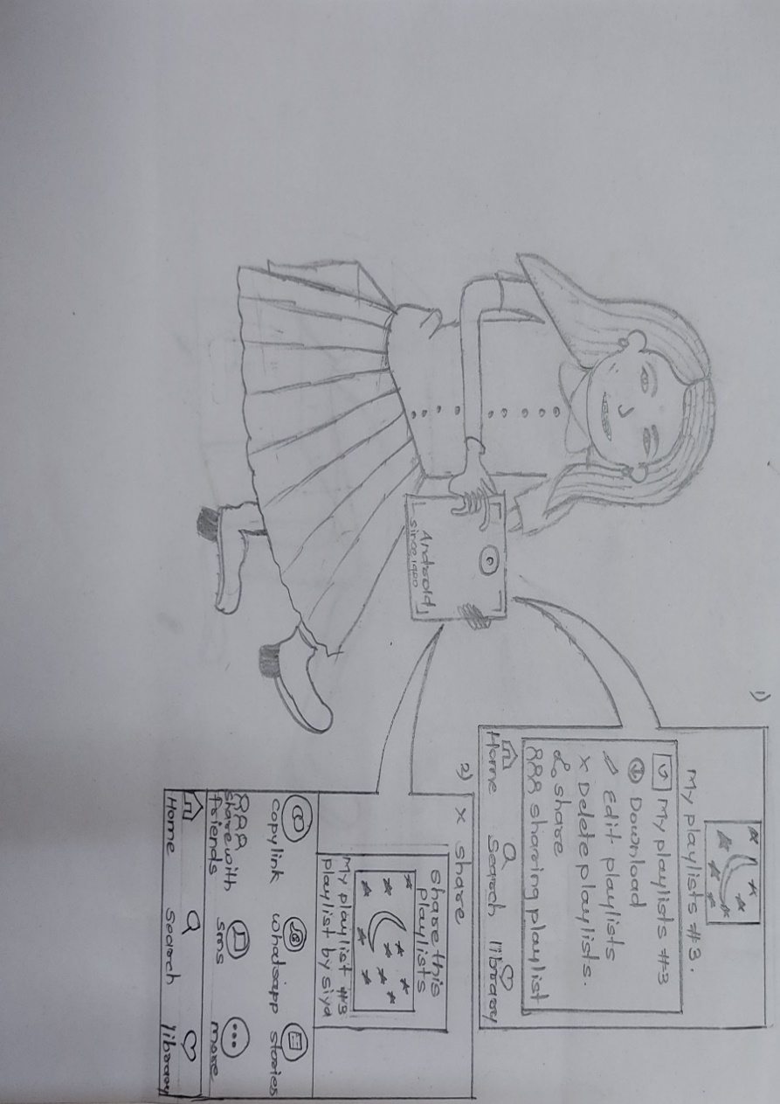

**d. Wireframes**

**Task: Sharing Playlist**

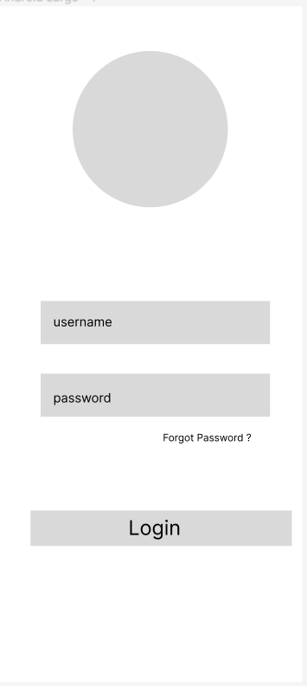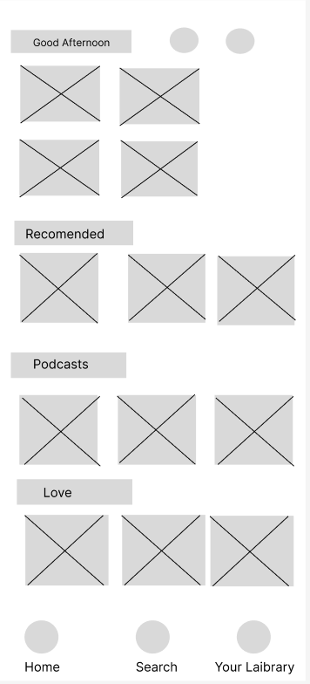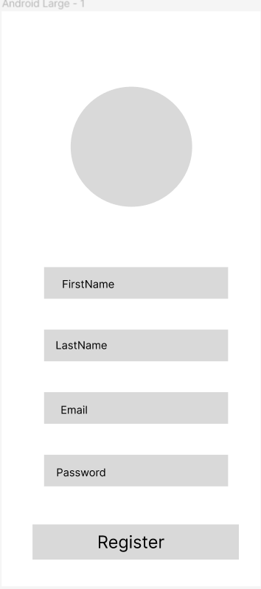

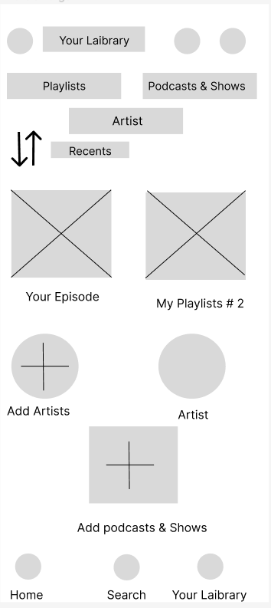

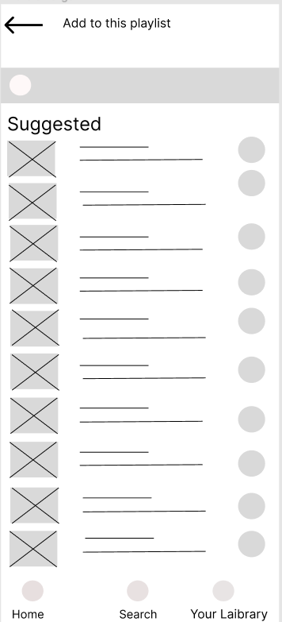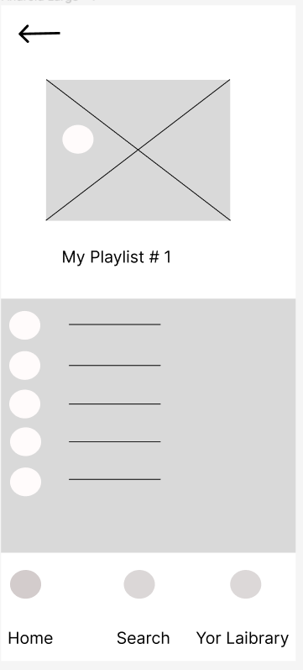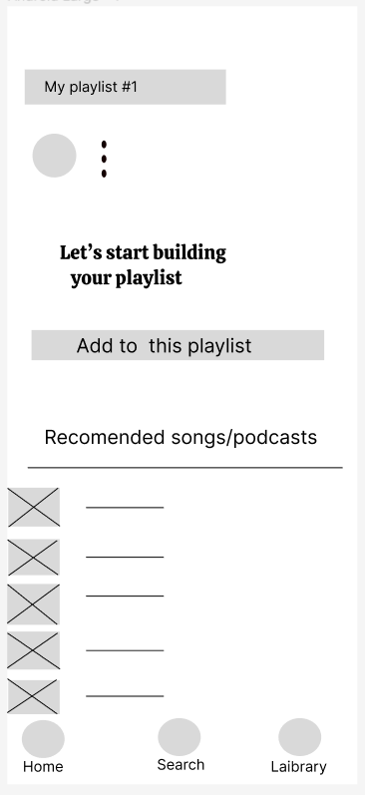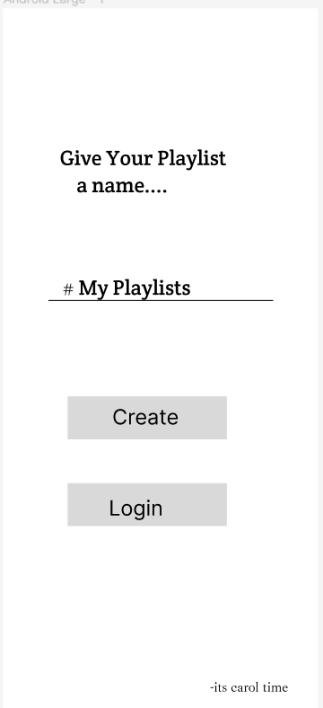

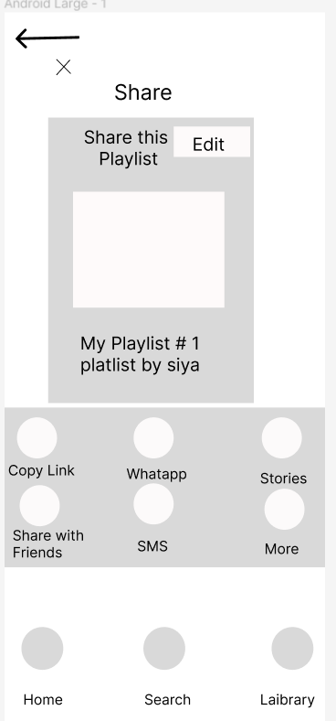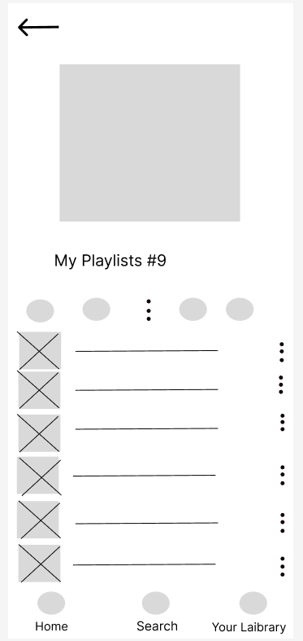

**Task 2:Verifying Artist Work**

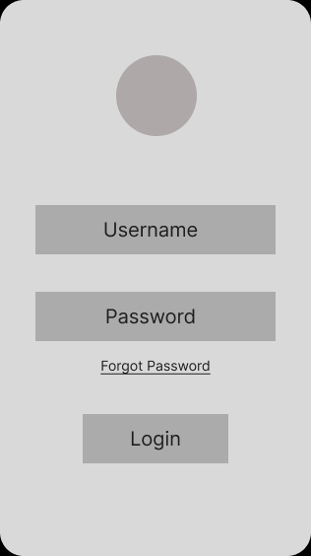 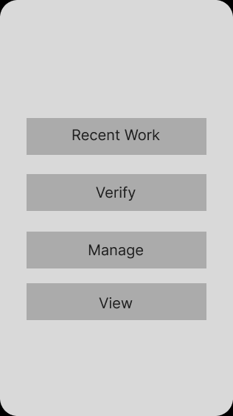

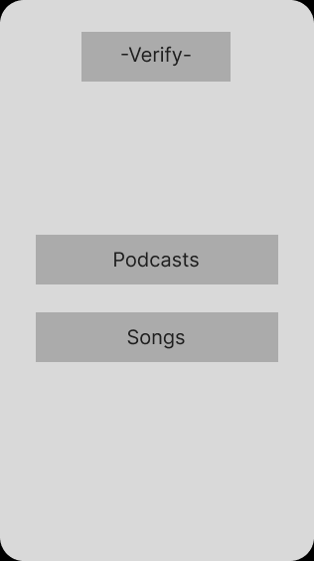 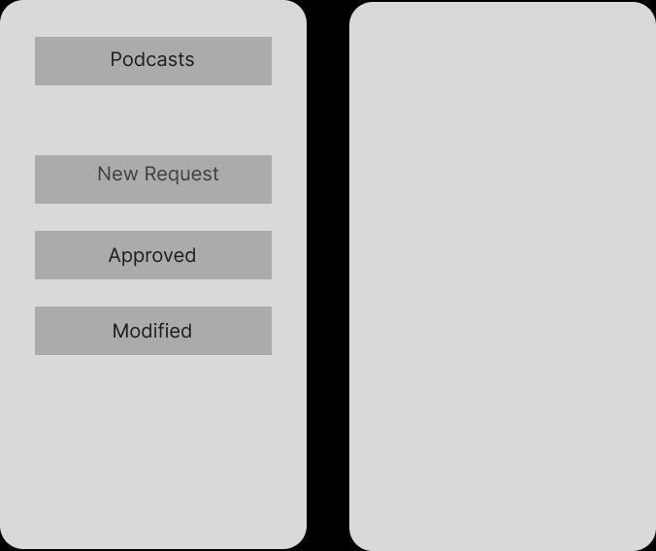

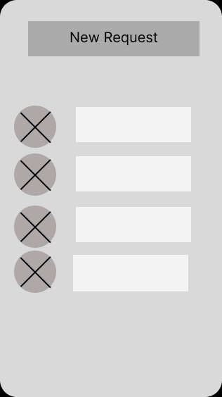 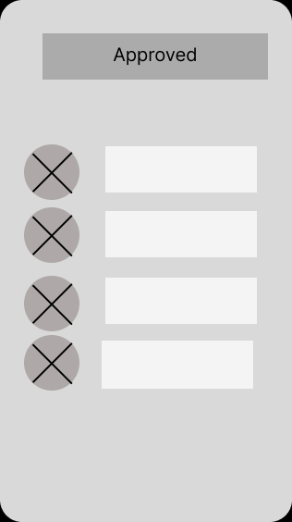

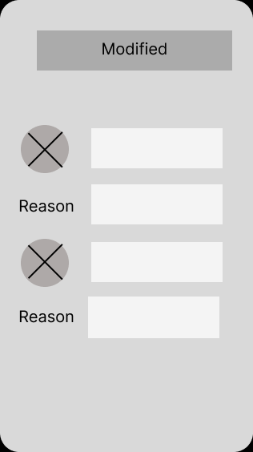

**e. Prototypes (Figma Screen)**

**Task : Search Podcast**

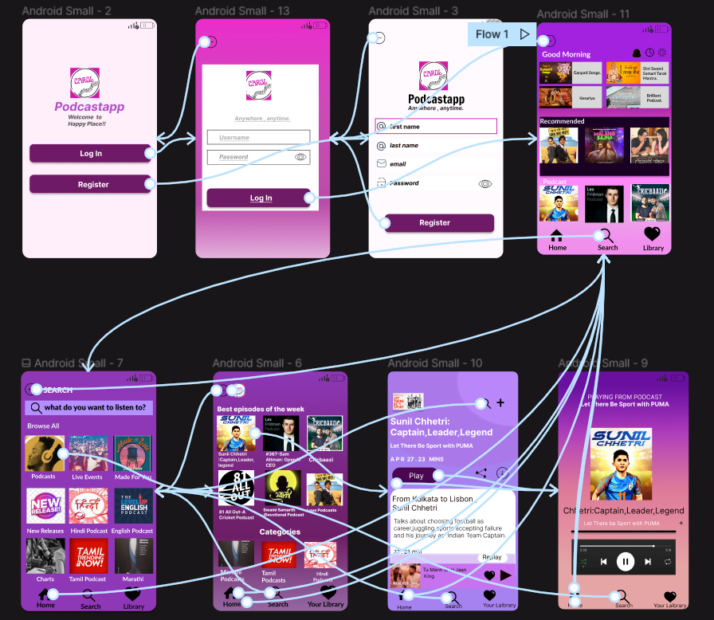

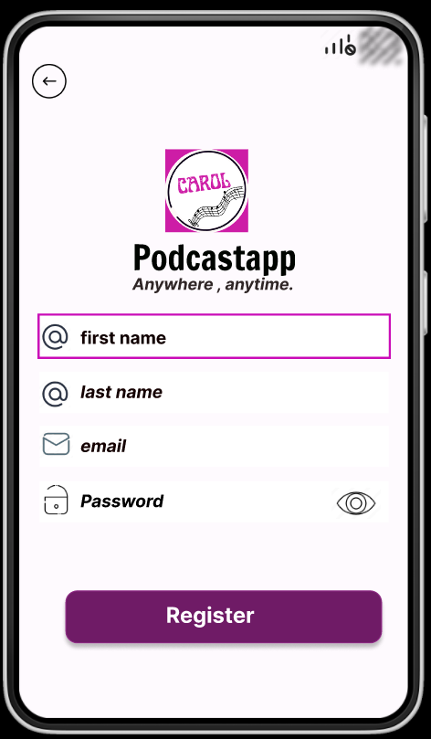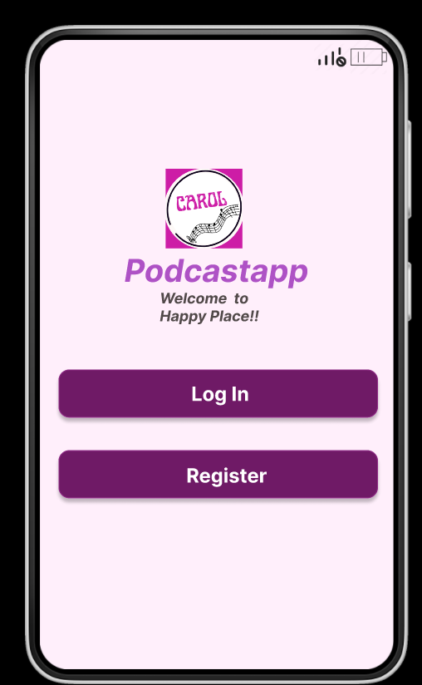

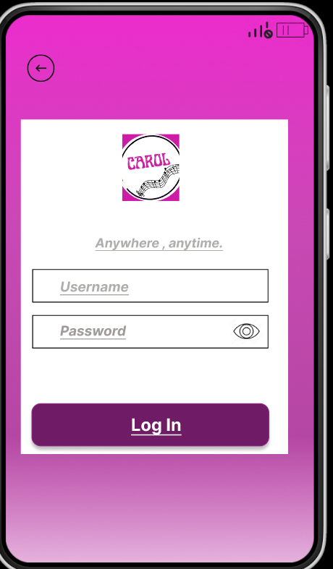 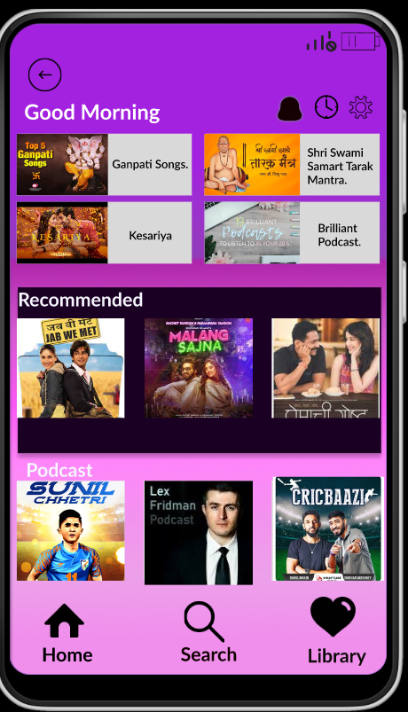

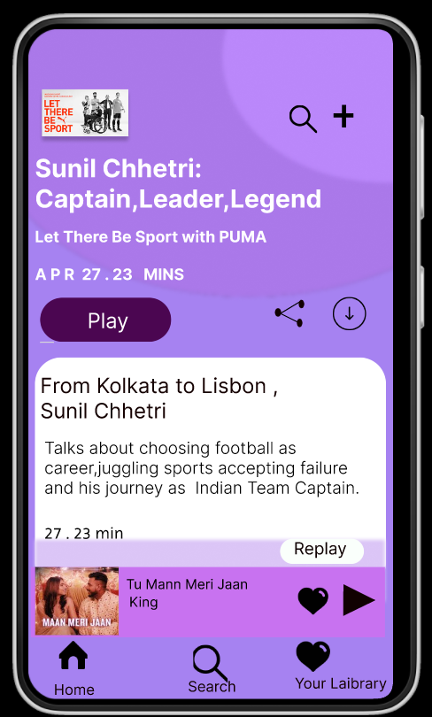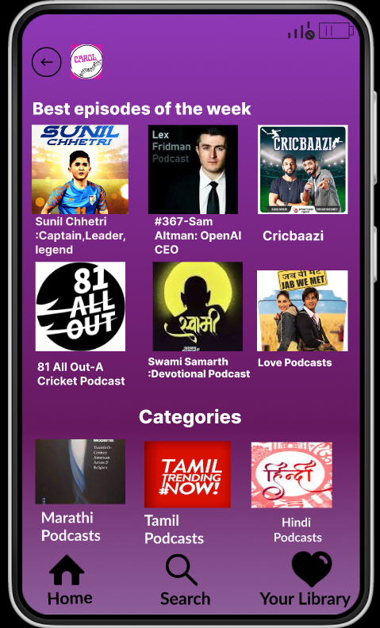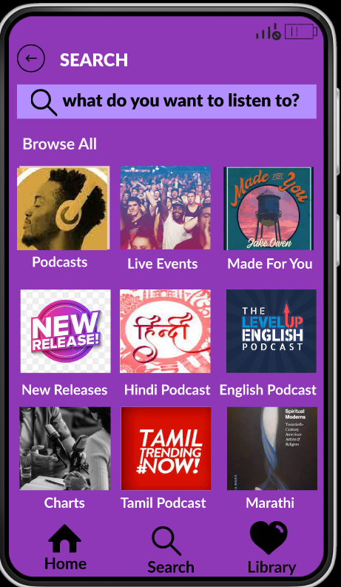

1. **Screens**

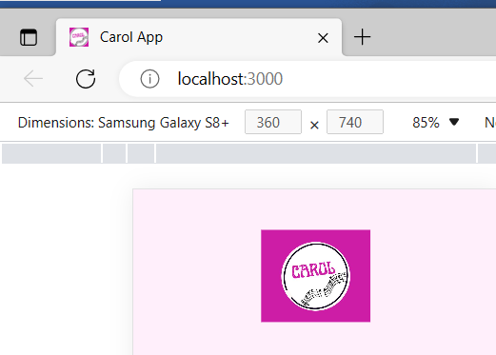

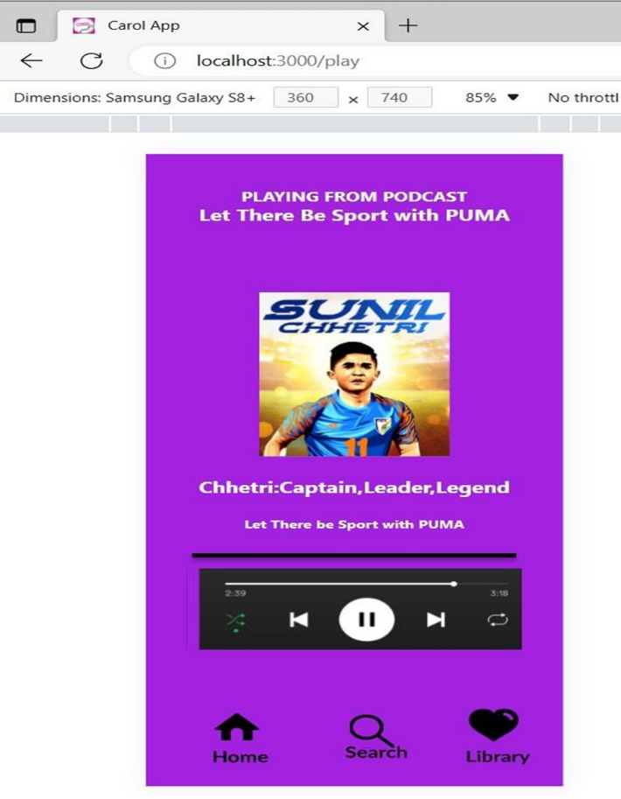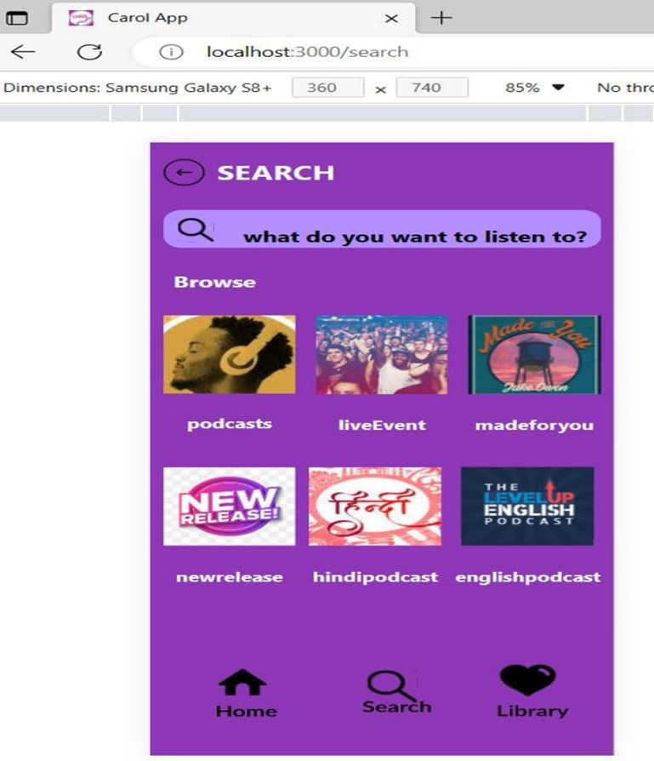

**6. Test Cases**

## User Test Cases:

**Task 2: Listen to a podcast episode**

|  |  |  |  |  |  |  |
| --- | --- | --- | --- | --- | --- | --- |
| Test Cases | Prerequisites | Test Scenarios | Test Steps | Expected Results | Actual Results | Pass/Fail |
| T0 | To Login | Visit the app, register into system | 1.Install application  2.Open the app  3.Click on Sign in  4.Fill the Appropriate details in the form  5.Click on Register.  6.Get login Credential | User Successfully register in application and Login Window open | As Expected | Pass |
| T02 | Access to app | Check Login and Crate new Window appears | 1. Open the   app   1. Click on Create Account 2. Also Click on Login | User should Login and Create Account window open | As Expected | Pass |
| T03 | The user has the Carol application open. | 1. Search for the podcast using the search bar.2. Browse for the podcast using the categories. | 1. Open the Carol application.2. Tap on the search bar.3. Type in the name of the desired podcast.4. Tap on the search button.5. Alternatively, tap on the categories tab.6. Tap on the desired category.7. Scroll through the list of podcasts until the desired podcast is found. | The user should be able to find the desired podcast using the search bar or categories | As Expected | Pass |
| T04 | The user has found the desired podcast. | 1. Select the most recent episode.2. Select a specific episode. | 1. Tap on the desired podcast to open it.2. Alternatively, tap on the "Episodes" tab.3. Tap on the most recent episode.4. Alternatively, scroll through the list of episodes until the desired episode is found.5. Tap on the desired episode to select it. | The user should be able to select the most recent episode or a specific episode. | As Expected | Pass |
| T05 | The user has the Carol application open and has selected the desired episode | 1. Tap on the "Play" button.2. Tap on the episode title. | 1.Tap on the "Episodes" tab.2. Scroll through the list of episodes until the desired episode is found.3. Tap on the desired episode to select it.4. Tap on the "Play" button to start playing the episode.4. Alternatively, tap on the episode title to start playing the episode. | - The episode should start playing.- The user should be able to hear the audio of the episode. | As Expected | Pass |

**Task 3 : Sharing a playlist.**

|  |  |  |  |  |  |  |
| --- | --- | --- | --- | --- | --- | --- |
| Test Cases | Prerequisites | Test Scenarios | Test Steps | Expected Results | Actual Results | Pass/Fail |
| T0 | To Login | Visit the app, register into system | 1.Install application  2.Open the app  3.Click on Sign in  4.Fill the Appropriate details in the form  5.Click on Register.  6.Get login Credential | User Successfully register in application and Login Window open | As Expected | Pass |
| T02 | Access to app | Check Login and Crate new Window appears | 1. Open the   app   1. Click on Create Account 2. Also Click on Login | User should Login and Create Account window open | As Expected | Pass |
| T03 | The user has logged in to the Carol application. | 1. Click on the Library icon from the home screen.2. Click on the "Library" tab from the bottom navigation. | 1. Open the Carol application.2. Tap on the Library icon on the home screen. 3. Alternatively, tap on the "Library" tab from the bottom navigation | The user should be able to navigate to the "Library" section of the Carol application. | As Expected | Pass |
| T04 | The user has navigated to the "Library" section of the Carol application. | 1. Click on the "My Playlist" tab from the library section.2. Search for the playlist by typing the name in the search bar. | 1. Open the Carol application.2. Navigate to the "Library" section of the Carol application.3. Tap on the "My Playlist" tab.4. Alternatively, tap on the search bar and type in the name of the desired playlist.5. Tap on the search button. | - The user should be able to see the "My Playlist" section.- If searching, the user should be able to see the search results and find the desired playlist. | As Expected | Pass |
| T05 | The user has navigated to the desired playlist. | 1. Click on the three-dot icon next to the playlist.2. Click on the playlist to open it. | 1. Open the Carol application.  2. Navigate to the "Library" section of the Carol application.  3. Tap on the "My Playlist" tab.  4. Search for the desired playlist by typing the name in the search bar or scrolling through the list of playlists.  5. Tap on the desired playlist to open it. | 1.The user should be able to share playlist2:The user should be presented with various sharing options. | As Expected | Pass |
| T06 | The user has navigate sharing option | 1. Click on Playlist2. Click on the sharing playlist | 1. Open the Carol application.2. Tap on the Library icon on the home screen.3. Alternatively, tap on the "Library" tab from the bottom navigation4.Tap on the "My Playlist" tab5.tap on 3 icons to share playlist5.Choose option for sharing playlist . | 1.The user should be able to share playlist2. The user should share playlist with clicking sharing option. | As Expected | Pass |

**8. Future Enhancement**

While the initial development of the podcast app focuses on meeting the core functionality requirements, there are several potential future enhancements that can further improve the application and provide additional value to users.

These enhancements include:

Cloud Storage Integration: Integration with popular cloud storage services, such as Dropbox or Google Drive, to allow users to store and access their music collections directly from the cloud, providing seamless synchronization across devices.

Social Media Integration: Adding social media integration features, allowing users to share their favorite songs or playlists with friends on platforms like Facebook, Instagram, or Twitter, and even allowing for collaborative playlist creation.

Smart Speaker Integration: Integration with smart speaker devices, such as Amazon Echo or Google Home, to enable users to control the music playback using voice commands and enjoy a hands-free music listening experience.

Enhanced Music and podcast Discovery: Expanding the personalized recommendations feature to include more advanced algorithms and machine learning techniques, providing users with highly accurate and tailored music recommendations based on their individual preferences and listening habits.

Podcast Support: Adding support for podcasts, enabling users to subscribe, download, and listen to their favorite podcasts directly within the application, enhancing the versatility of the music player as an all-in-one audio content platform.